# CS 419 Compiler Projects Form

1. **Instructions to be Followed (for the Hard Copy):**
   1. Fill page **NO 4** with the required Fields:
      1. Project Idea: The **Idea** will be assigned to you .
      2. Team Members NO#: Number of team members **7**
      3. Table:
         * ID: Your FCIH ID.
         * Name: Your **Full Name** as registered on College’s Database.
         * Level & Department: Your **(Current)** level and department.
         * Section(Day-from-to): Your Section Day and time slot.
         * Role: Your role in project (**Team leader** OR **Member**).
         * Fill Page **NO 5 & 6** with your (**Regular Expressions**, **Finite automata**, **Parse trees** and **abstract syntax tree**) respectively.
2. **Minus Policies:**
   1. **Project Policy:** affects all projects members including team leader.
   2. **Member Policy:** affects a member of project’s members.
3. **General Notes:**
   1. Total grade of Project is 15
   2. **Deadline** to register yourself and your team on online form **Tuesday 05/04/2022 at 11:59 PM** after that **-2 Project Policy** will be applied**.**
   3. Once you Registered, **NO modifications** will be done.
   4. Allowed only on registration for team in form, duplication will got **-2 Project Policy.**
   5. Each group will be assigned **an Idea, ID and time slot** for **discussion**.
   6. Each team member and team leader in a team **must work in project’s coding phase** (including implementation of **finite automata and parse trees**).
4. **Discussion Notes:**
   1. **Copied Code** will be got ZERO Without Discussion.
   2. By references to Section 3 (General notes) Point V , **-5 Member policy** will be applied to each team member (including team leader) who does not participate in project coding phase **as well as the team leader who does not report this case**.
   3. Each team member must have **a complete knowledge** about the whole project
   4. **Evaluation** will be **Individual Evaluation** not project Evaluation.
   5. **-2 Project Policy** will be applied in case of being late for assigned discussion time slot
   6. **NO discussion will be repeated under any circumstances.**
   7. At Discussion day, in case of offline discussions, each team must have **Hard Copy form** including (**Finite automata and parse trees of team’s project**).
   8. Discussion Day will be **sent later** .

## Notes about Implementation:

* 1. **.Net or PHP** are only allowed.
  2. The project must be a Web (use latest technologies).
  3. Your code must be uploaded to github before discussion.
  4. **- 5 Project policy** will be applied in case of using **Built-in Method** within implementation of the scanner or parser, you must create your **own methods to match** for ex (your regular Expressions).
  5. Each Project must contain a full functional editor (comment, uncomment, put red line under wrong words, auto complete, navigation to function or class, line NO).
  6. Each Project must contain **two buttons** , one button called “**Scan**” to run scanner and other called “**Parse**” to run parser –parser must take output of scanner to do it’s task.
  7. Each project must contain a button named “**Browse**” that allows us to choose a **file from a disk** that allows us to parse or scan this file **Without Showing what is inside the file** and shows the output.
  8. – 3 Project policy will be applied if the content of the file that is mentioned in point V is opened or viewed.

## Notes about Discussion Testing:

* + There will be two types of Testing :

1. **White Box Testing:** This will be from **Editor**.
2. **Black Box Testing:** This will be from “**Browse**” Button

**Thanks,**

# CS 419 Compiler Project Form

**Project Idea:**

………Project 1……………………………………………………….

**Team Members NO#:** ……19……………………………..

|  |  |  |  |  |  |
| --- | --- | --- | --- | --- | --- |
| **ID** | **Name** | **Level& Department** | **Section(Day- from-to)** | **Role (Lead/Member)** | **Grade** |
| 201900477 | عزت علي عبد الرحمن | 3/cs |  | Leader |  |
| 201900353 | سمير احمد محمد رضوان | 3/cs |  | Member |  |
| 201900374 | شوقي سيد شوقي | 3/cs |  | Member |  |
| 201900482 | علي احمد فتحي دسوقي | 3/cs |  | Member |  |
| 201900501 | عمر اسامه محمد صابر | 3/cs |  | Member |  |
| 201900158 | اكرم سمير سيد حسين | 3/cs |  | Member |  |
| 201900476 | عز الدين اشرف محمد ابراهيم | 3/cs |  | Member |  |

## Regular Expression, Finite automata and Conversion from RegX to NFA, NFA to DFA

**Regular expressions:**

|  |  |
| --- | --- |
| Constants | ([0-9]+(\.[0-9]+)?) |
| String | ("(.*)") |
| Reserved Keywords | (Iow|SIow|Chlo|Chain|Iowf| SIowf |Worthless|LoopWhen|IterateWhen|Turnback|Stop|Loli|Include|if||else) |
| Multiple Comment Statement | ((\/\$)(.*)(\$\/)) |
| Single comment statment | (($$$)(.*)($$$)) |
| Identifiers | ([(_)a-zA-Z][(_)a-zA-Z0-9]*) |
| Arithmetic Operators | (\+|-|\*|\/) |
| relational Operators | (<|!=|>|==|<=|>=) |
| Logic Operator | (&&|\|\||\~) |
| Assignment Op | (=) |
| Access operator | (->) |
| Braces | ({|}|[|]|(|)) |
| Quotation mark | (“|’) |

**Dfa:**

**Assignment Operator**

**Access Operator**

**Braces**

**Logical Operator**

**Relational Operator**

**Arthimatic operations**

**Constants(Numbers)**

**Quotation mark**

**Multiple line comment**

**Single line comment**

**Identifiers**

**Reserved Keywords**

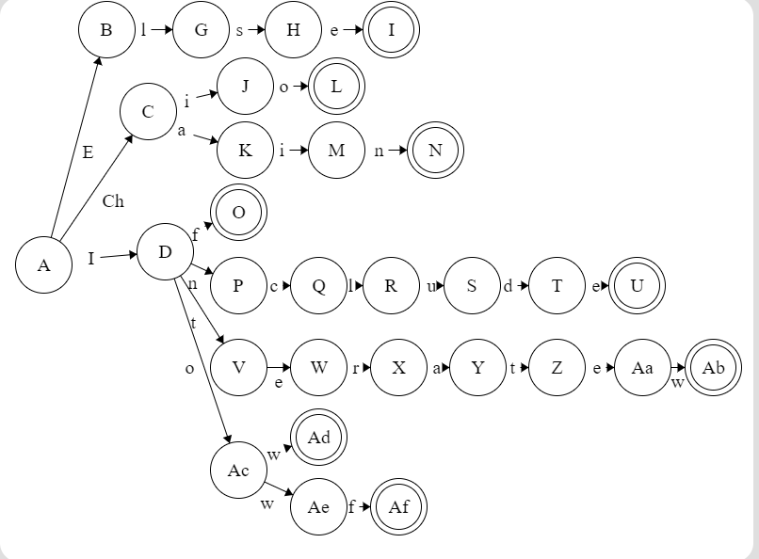

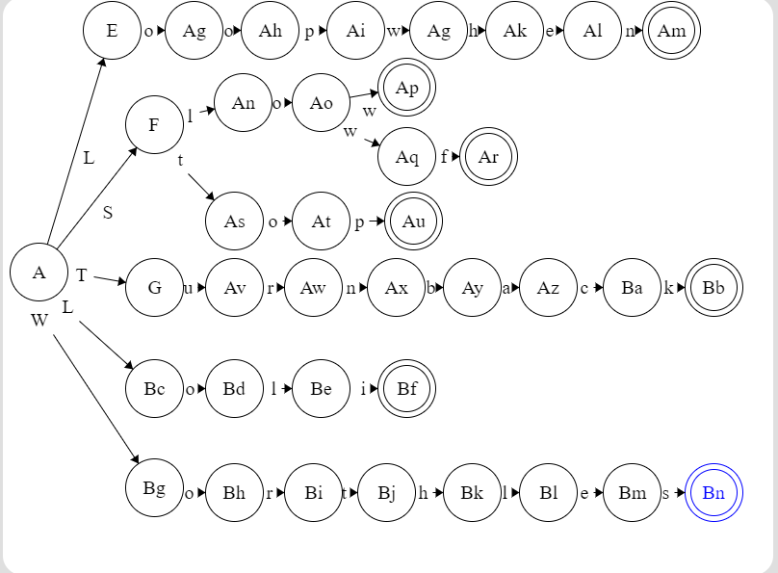

**Parse tree and Abstract syntax tree**